**Movie Recommendation Web Service / recommendationInfo()**

Function

RecommendationInfo : print the recommendation result

Description

Receive the data about matching relevant movies and Print this data to user.

Inputs

result of matching relevant movies

Source

result of matching relevant movies from matching function

Outputs

RecommendedList - Processed List of matching relevant movies for user to see easily

Destination

None

Actions

RecommendedList is the result of edited list. From received data, edit the list sorted from high-score movies to low-score movies(descending order). List shows movie's name, genre, and relative score from matching.

Pre-condition

None

Post-condition

None

Side effects

None

**Movie Recommendation Web Service / loadMovieInfo()**

Function

Load movie information from database

Description

Load the movie information from the database server according to the input.

Inputs

Variety of required movie information

Source - None

Outputs

movie list – list of required movie information

Destination - None

Action

Get movie information from the database. It receives a variety of movie information (e.g., a list of recommended movies or a list related to a searched movie) as input of a function, and outputs the corresponding information as a list.

Pre-condition - None

Post-condition - None

Side effects - None

**Movie Recommendation Web Service / provideMovieInfo()**

Function

provide information received

Description

Provide movie information to users which they required

Inputs

movie list from LoadMovieInfo

Source - None

Outputs

edited movie list

Destination - None

Action

Print out the movie information received by input on the screen. The movie information that comes into Input is a movie list received from loadMoiveInfo. The information is printed on the user's screen in tabular format.

Pre-condition - None

Post-condition - None

Side effects - None

**Movie Recommendation Web Service / askPreference()**

Function: ask preference

Description

Ask users about their preference about movie. Let them choose their preferred movie in list. And compute user’s preferred movie genre score .

Inputs

User’s preferred movie.

Output

user’s preferred genre score

Source : none

Destination : none

Action

The website asks users to choose their preference. Function computes each movie’s genre score and makes a matrix about the user's preferred genre score matrix. This matrix is to recommend movies. This matrix contains scores of preference for each genre.

Requirements

Users need to choose large enough movies to get more precise recommendation

Pre-condition none

Post-condition none

Side effects none

**Movie Recommendation Web Service / matching()**

Function: matching

Description

After computing user’s preferred genre score, with it, Compute list for recommending movie.

Input

User’s preferred genre score

Output

A list of movies which this program recommends

Source none

Destination none

Action

In user’s preferred genre score, We compute score for the movie. We assume that there are each genre scores for movie. For example, A movie has 10points for action, 0 points for romance. After combining score (computing score), This function make list for recommendation.

Requirements

Precise user’s preferred score matrix.

Pre-condition none

Post-condition none

Side effects none

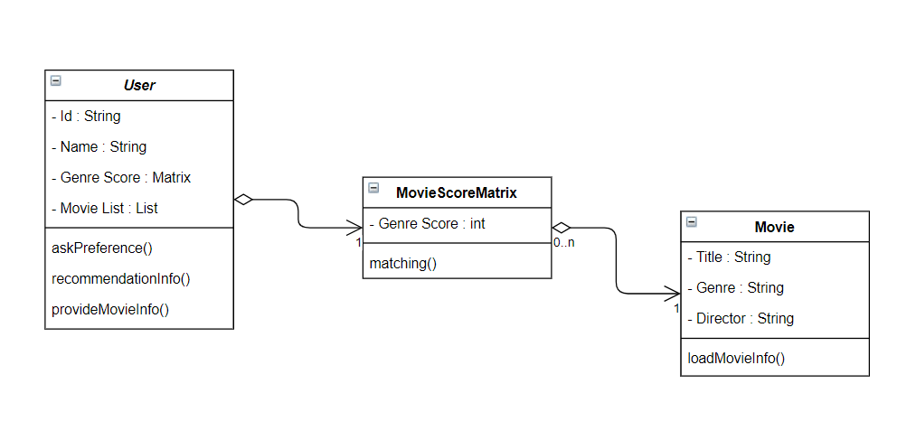

movie - 각 장르에 대한 정보 /점수

movie class matrix

user - list movie user 선호도(scored matrix)

on, …;